**Course Specialist Year 12 Test One 2022**

Student name: ________________ Teacher name: ________________

**Task type: Response**

**Time allowed for this task: _____40______ mins**

**Number of questions: _____8______**

**Materials required:** Calculator with CAS capability (to be provided by the student)

Standard items: Pens (blue/black preferred), pencils (including coloured), sharpener, correction fluid/tape, eraser, ruler, highlighters

Special items: Drawing instruments, templates, notes on one unfolded sheet of   
A4 paper, and up to three calculators approved for use in the WACE examinations

**Marks available: __42____ marks**

**Task weighting: _10___%**

**Formula sheet provided: Yes/No**

**Note: All part questions worth more than 2 marks require working to obtain full marks.**

Q1 (2, 3 & 3 = 8 marks)

Let and .



Simplify the following.



| **Solution** |
| --- |
|  |
| **Specific behaviours** |
| ✓ real part  ✓ imaginary part |



| **Solution** |
| --- |
|  |
| **Specific behaviours** |
| ✓ shows use of conjugate  ✓ numerator  ✓ denominator |



| **Solution** |
| --- |
|  |
| **Specific behaviours** |
| ✓ shows use of conjugate or uses result from b but only if conjugate shown  ✓ shows how to multiply numerators  ✓ simplified expression |

Q2 (3 marks)

Determine all possible real number pairs such that



| **Solution** |
| --- |
|  |
| **Specific behaviours** |
| ✓ equates real and imaginary parts of two expressions  ✓ sets up two simultaneous equations  ✓ solves for two exact pairs of values |

Q3 (3 marks)

Consider the polynomial where are real numbers.



Given that and determine the values of .



| **Solution** |
| --- |
|  |
| **Specific behaviours** |
| ✓ uses conjugate root  ✓ solves for one constant  ✓ solves for all 3 constants |

Q4 (3 marks)

Using the diagram below determine the complex number in exact cartesian form.



(Note: Not drawn to scale)

| **Solution** |
| --- |
|  |
| **Specific behaviours** |
| ✓ determines argument of w  ✓ determines modulus of w  ✓ expresses in exact cartesian form |

Q5 (3 & 3= 6 marks)

Sketch the locus for the following labelling important features and points.

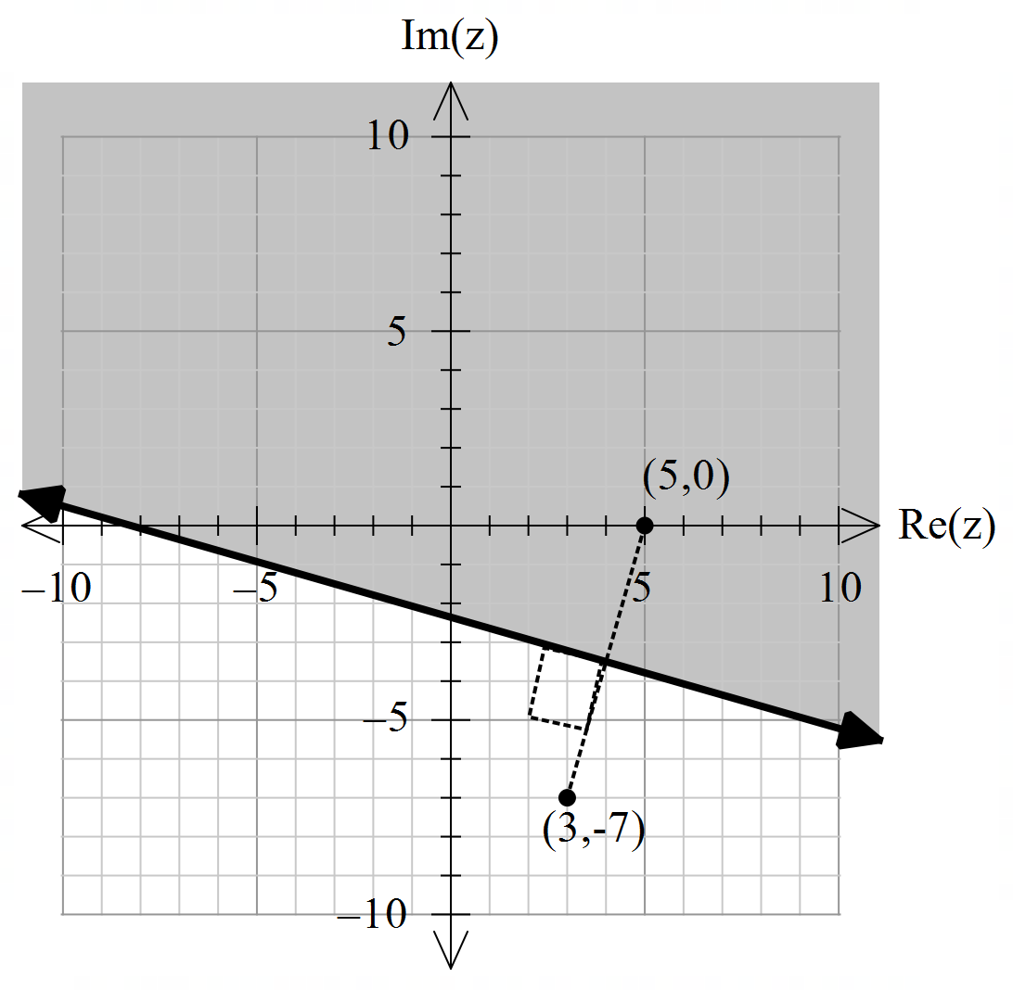

| **Solution** |
| --- |
|  |
| **Specific behaviours** |
| ✓ plots endpoints  ✓ draws perpendicular bisector & indicates right angle  ✓ shades correct region |

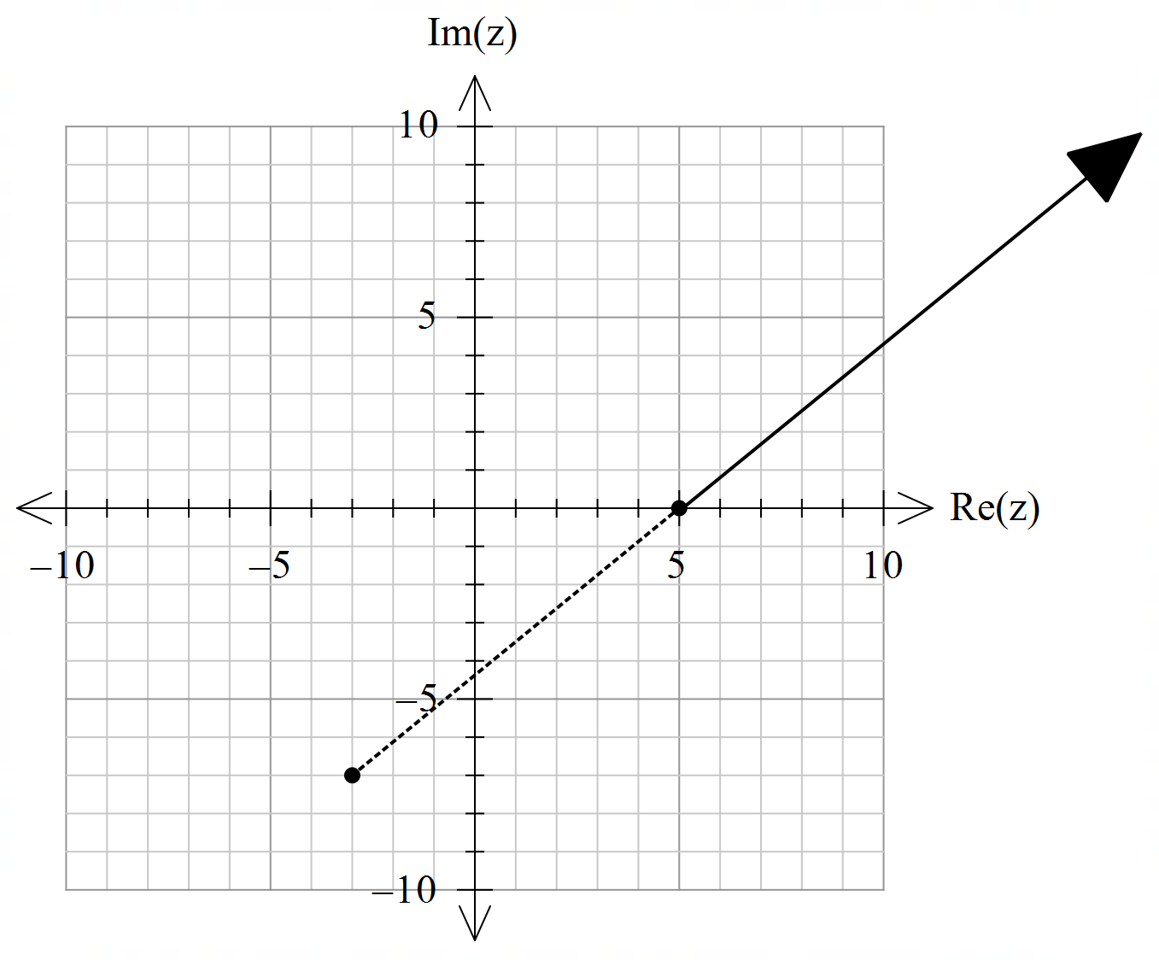

| **Solution** |
| --- |
|  |
| **Specific behaviours** |
| ✓ plots pts (-3,-7) & (5,0)  ✓ shows dotted line between  ✓ plots locus line |

Q6 (2 & 4 = 6 marks)

Consider the set of points in the complex plane such that .

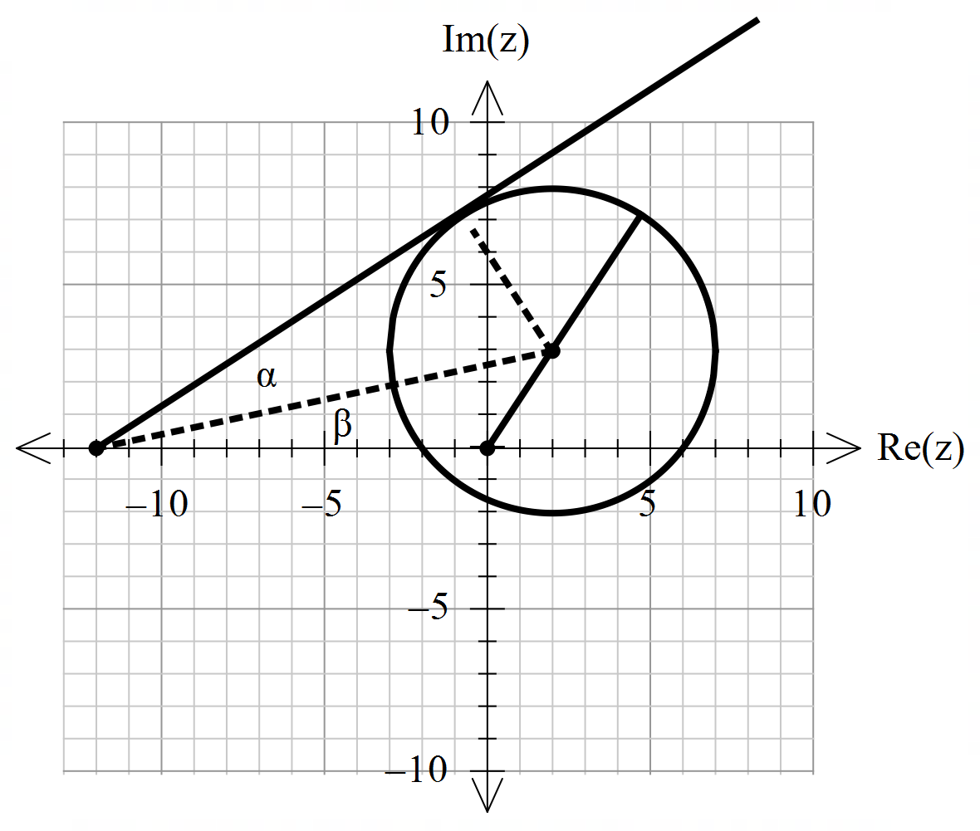

1. Determine the maximum value of .



8.605551275

| **Solution** |
| --- |
|  |
| **Specific behaviours** |
| ✓ determines modulus of centre  ✓ adds radius (approx.) |

1. Determine the maximum value of the .



| **Solution** |
| --- |
|  |
| **Specific behaviours** |
| ✓ uses tangent line from (-12,0)  ✓ determines alpha angle  ✓ identifies right angle for beta triangle and determines two side lengths  ✓ determines sum of alpha & beta angles (see diagram) |

Q7 (4 marks)

Using De Moivre’s Theorem, derive an expression for in terms of .



| **Solution** |
| --- |
|  |
| **Specific behaviours** |
| ✓ sets up equation for power 4 and uses De Moivre’s  ✓ states expression for power 4  ✓ equates imaginary parts of both sides  ✓ states required expression |

Q8 (4, 2 & 3 = 9 marks)

1. Solve for all the roots in polar form with .



| **Solution** |
| --- |
|  |
| **Specific behaviours** |
| ✓ converts RHS to polar  ✓ demonstrates use of De Moivre’s  ✓ determines modulus of all roots  ✓ determines principal arguments |

1. Plot these roots on the complex plane below.

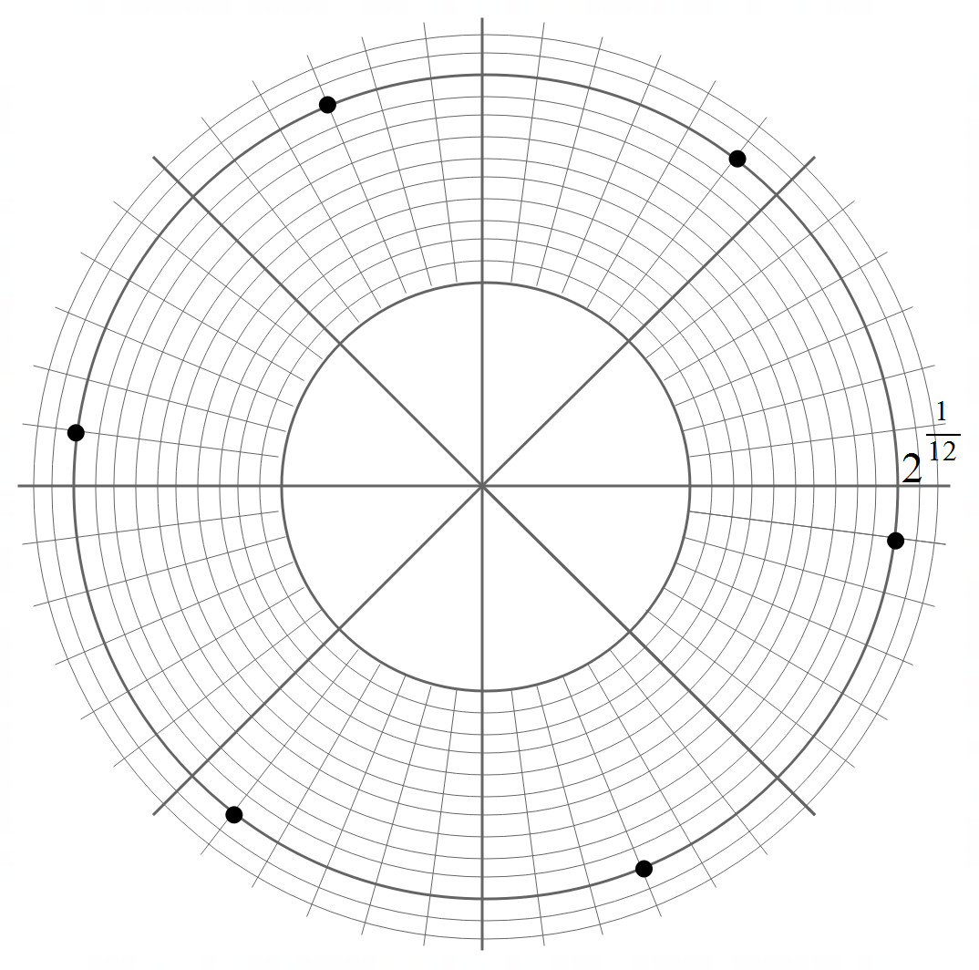

| **Solution** |
| --- |
|  |
| **Specific behaviours** |
| ✓ shows scale and equally distance  ✓ all positions correct |

1. Adjacent points can be joined by lines to form a polygon. Determine the exact area of this polygon.

| **Solution** |
| --- |
|  |
| **Specific behaviours** |
| ✓ identifies equilateral triangles  ✓ determines side lengths  ✓ shows calculation for total exact area |

Working out space

Working out space